# 2.0 Librería Flutter

# Android Estudio V3.0.17/Flutter

Objetivo:Bucear

F.Creación: 9-4-2018

Programa:

Fuente: [Fuente de Flutter](https://github.com/flutter/flutter)

# flutter-master\examples\catalog\lib

## 2.1 animated_list.dart

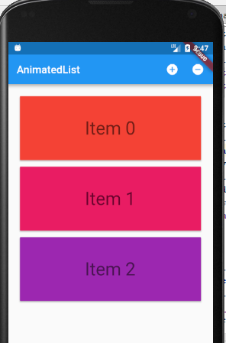

Librería **import 'package:flutter/foundation.dart'**;

## 2.2 animated_list.dart

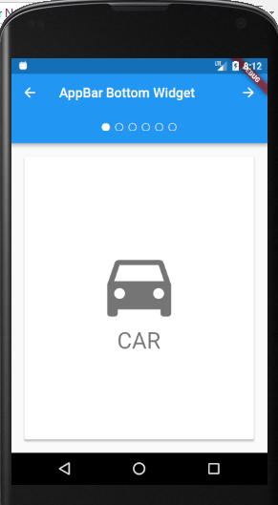

Librería **import 'package:flutter/material.dart'**;

## 2.4 custom_a11y_traversal.dart

